# Describe Service

kubectl describe service my-first-service

Access Application

http://<External-IP-from-get-service-output>

another public ip address is created

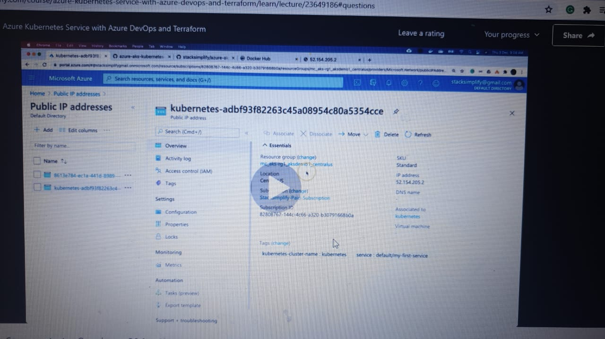

another front end ip address is created

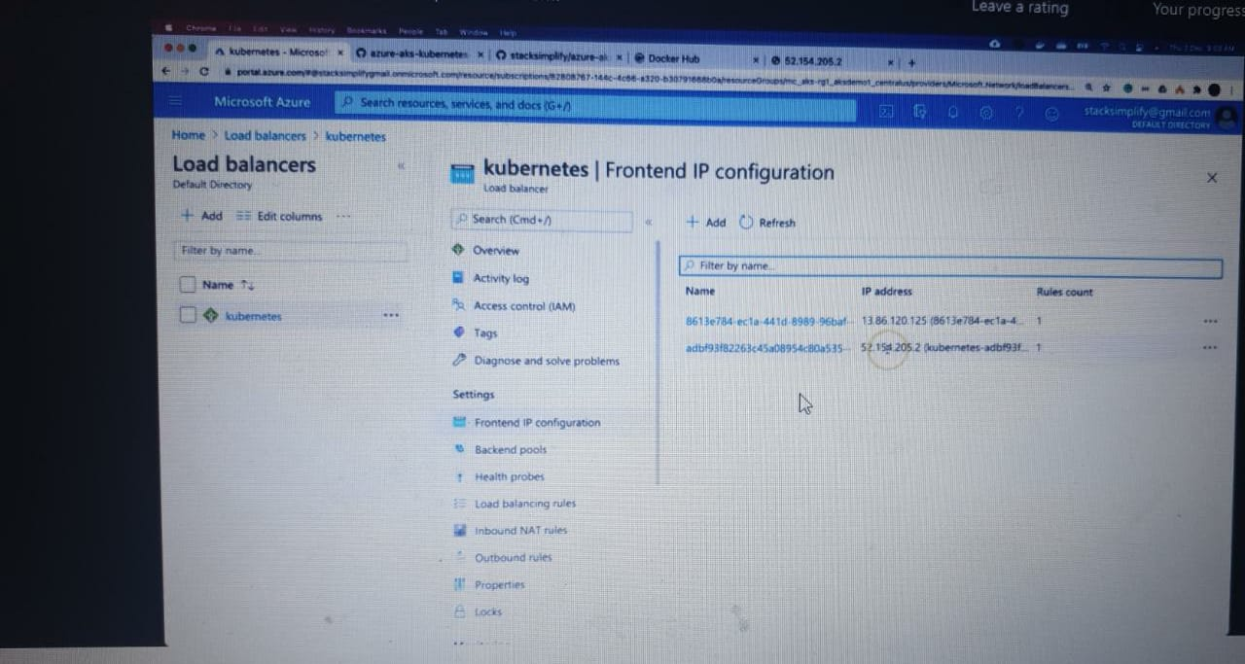

load balancer ip created

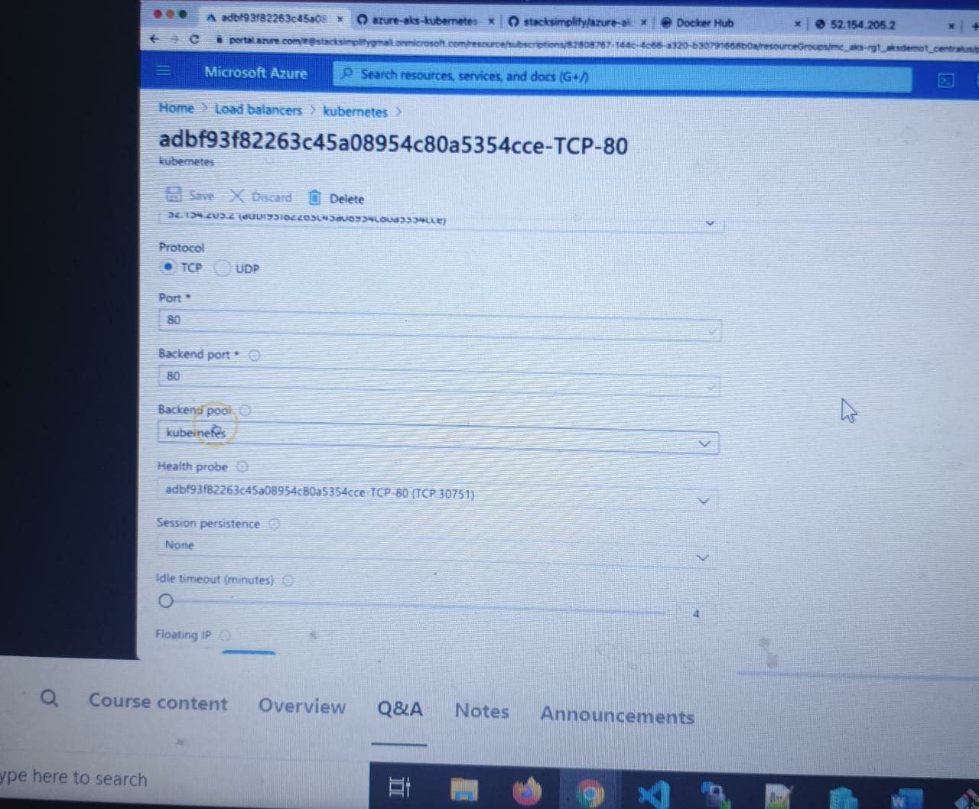

mapping the front end ip and health probe is automatically created

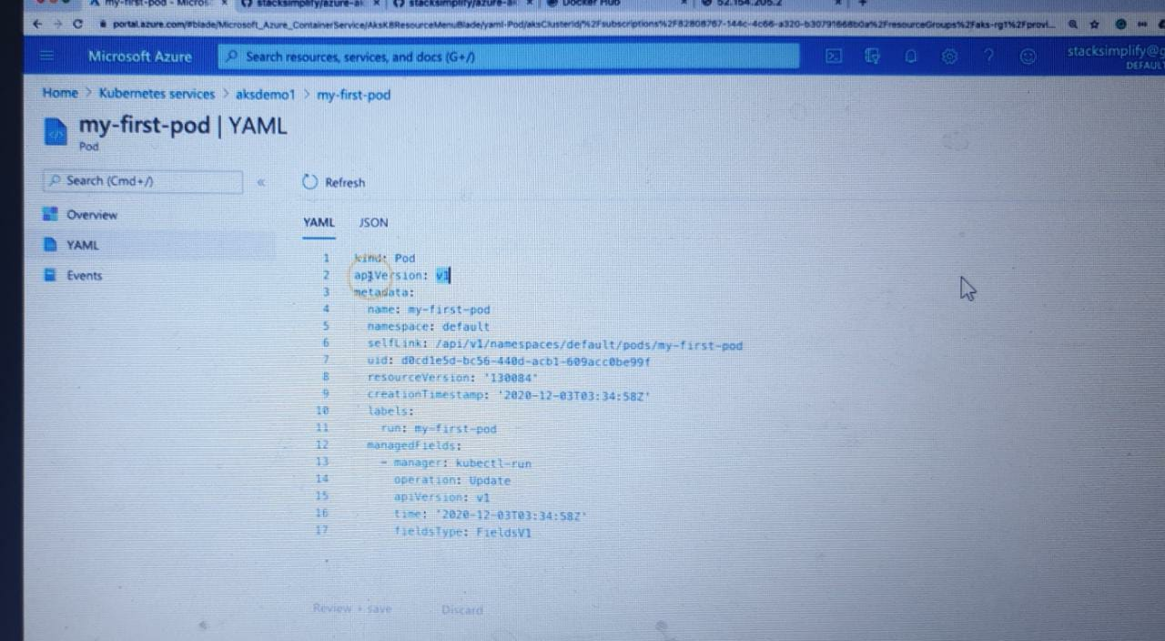

Pod YAML

pod yaml we can see it in the workloads section

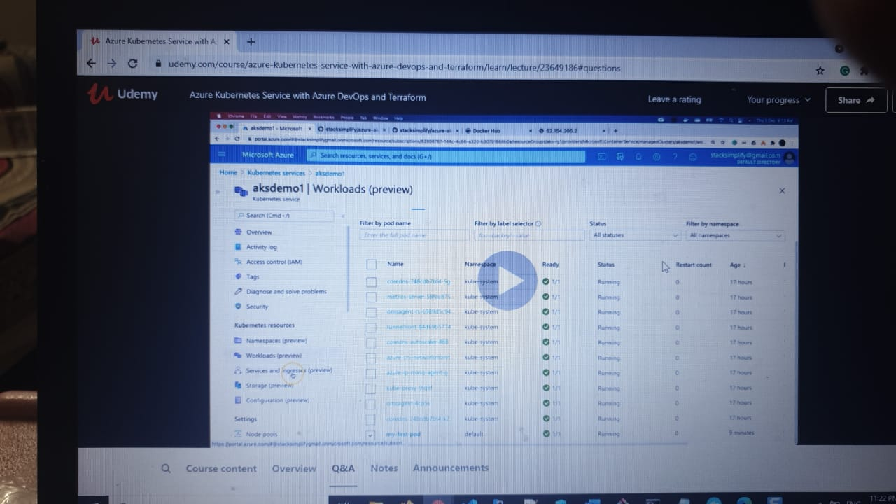

Interact with a Pod

Verify Pod Logs

: kubectl logs my -first pod

# Get Pod Name

kubectl get po

# Dump Pod logs

kubectl logs <pod-name>

kubectl logs my-first-pod

# Stream pod logs with -f option and access application to see logs

kubectl logs <pod-name>

kubectl logs -f my-first-pod

Important Notes

Refer below link and search for Interacting with running Pods for additional log options

Troubleshooting skills are very important. So please go through all logging options available and master them.

Reference: https://kubernetes.io/docs/reference/kubectl/cheatsheet/

Connect to Nginx Container in a POD

kubectl exec -it <pod-name> -- /bin/bash

kubectl exec -it my-first-pod -- /bin/bash

# Execute some commands in Nginx container

ls*will give inside pod list*

whatever we see in the browser we can see the same in from below commands

cd /usr/share/nginx/html

cat index.html

exit

cat index.html

pod environmental information

kubectl exec -it my-first-pod -- env

kubectl exec -it my-first-pod -- ls

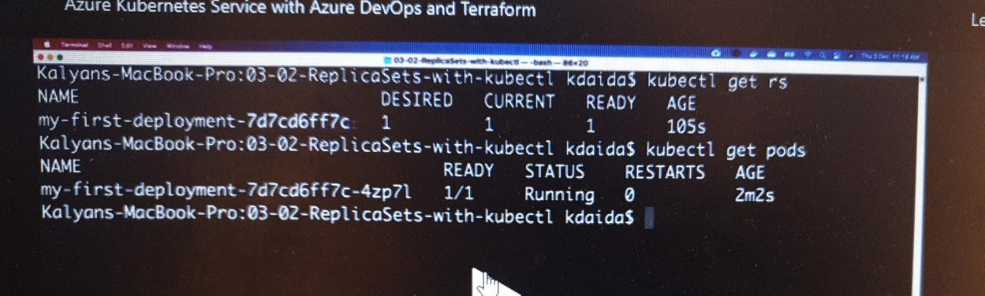 To see the if the pod is able to connect or not

kubectl exec -it my-first-pod -- cat /usr/share/nginx/html/index.html

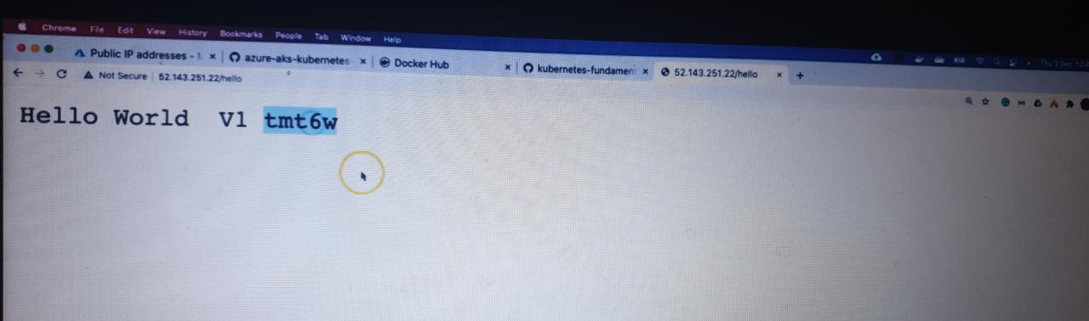

it is calling backend service

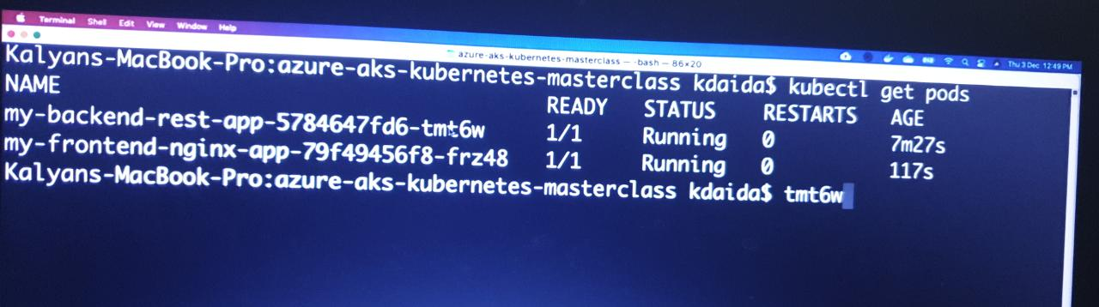

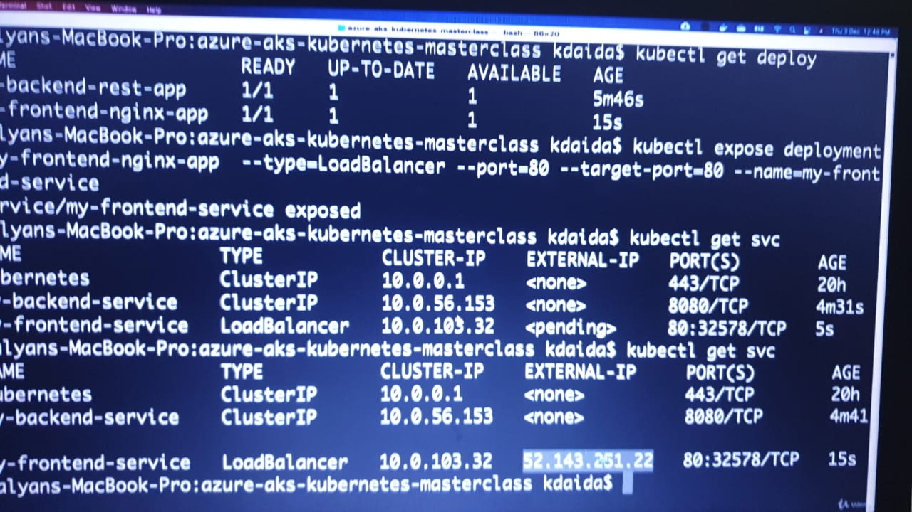

# Create a Pod

kubectl run <desired-pod-name> --image <Container-Image>

kubectl run my-first-pod --image stacksimplify/kubenginx:1.0.0

# Expose Pod as a Service

kubectl expose pod <Pod-Name> --type=LoadBalancer --port=80 --name=<Service-Name>

kubectl expose pod my-first-pod --type=LoadBalancer --port=80 --name=my-first-service

# Get Service Info

kubectl get service

kubectl get svc

# Describe Service

kubectl describe service my-first-service

# Access Application

http://<External-IP-from-get-service-output>

* Verify the following after LB Service creation
  + Azure Standard Load Balancer created for Azure AKS Cluster
    - Frontend IP Configuration
    - Load Balancing Rules
  + Azure Public IP
* View the resources in Azure AKS Cluster - Resources section from Azure Portal Management Console

## Step-05: Interact with a Pod

### Verify Pod Logs

# Get Pod Name

kubectl get po

# Dump Pod logs

kubectl logs <pod-name>

kubectl logs my-first-pod

# Stream pod logs with -f option and access application to see logs

kubectl logs <pod-name>

kubectl logs -f my-first-pod

* **Important Notes**
  + Refer below link and search for **Interacting with running Pods** for additional log options
  + Troubleshooting skills are very important. So please go through all logging options available and master them.
  + **Reference:** <https://kubernetes.io/docs/reference/kubectl/cheatsheet/>

### Connect to Container in a POD

* **Connect to a Container in POD and execute commands**

# Connect to Nginx Container in a POD

kubectl exec -it <pod-name> -- /bin/bash

kubectl exec -it my-first-pod -- /bin/bash

# Execute some commands in Nginx container

ls

cd /usr/share/nginx/html

cat index.html

exit

* **Running individual commands in a Container**

kubectl exec -it <pod-name> -- env

# Sample Commands

kubectl exec -it my-first-pod -- env

kubectl exec -it my-first-pod -- ls

kubectl exec -it my-first-pod -- cat /usr/share/nginx/html/index.html

## Step-06: Get YAML Output of Pod & Service

### Get YAML Output

# Get pod definition YAML output

kubectl get pod my-first-pod -o yaml

# Get service definition YAML output

kubectl get service my-first-service -o yaml

## Step-07: Clean-Up

# Get all Objects in default namespace

kubectl get all

# Delete Services

kubectl delete svc my-first-service

# Delete Pod

kubectl delete pod my-first-pod

# Get all Objects in default namespace

kubectl get all

and we can check

Step-09: Introduction to Kubernetes  
ReplicaSets

Replicas can be achieved by yaml file we can mention number of replicas/ or we can do it by kubectl scale functions/kubectl

### Create ReplicaSet

* Create ReplicaSet

kubectl create -f replicaset-demo.yml

* **replicaset-demo.yml**

apiVersion: apps/v1

kind: ReplicaSet

metadata:

name: my-helloworld-rs

labels:

app: my-helloworld

spec:

replicas: 3

selector:

matchLabels:

app: my-helloworld

template:

metadata:

labels:

app: my-helloworld

spec:

containers:

- name: my-helloworld-app

image: stacksimplify/kube-helloworld:1.0.0

vi replicaset-demo.yml (for editing the yml file)

:wq!

### List ReplicaSets

* Get list of ReplicaSets

kubectl get replicaset

kubectl get rs

### Describe ReplicaSet

* Describe the newly created ReplicaSet

kubectl describe rs/<replicaset-name>

kubectl describe rs/my-helloworld-rs

[or]

kubectl describe rs my-helloworld-rs

### Verify the Owner of the Pod

* Verify the owner reference of the pod.
* Verif y under **"name"** tag under **"ownerReferences"**. We will find the replicaset name to which this pod belongs to.

kubectl get pods <pod-name> -o yaml

kubectl get pods my-helloworld-rs-c8rrj -o yaml (To know the pod which replica set it is)

## Expose ReplicaSet as a Service

* Expose ReplicaSet with a service (Load Balancer Service) to access the application externally (from internet)

# Expose ReplicaSet as a Service

kubectl expose rs <ReplicaSet-Name> --type=LoadBalancer --port=80 --target-port=8080 --name=<Service-Name-To-Be-Created>

kubectl expose rs my-helloworld-rs --type=LoadBalancer --port=80 --target-port=8080 --name=my-helloworld-rs-service

# Get Service Info

kubectl get service

kubectl get svc

* **Access the Application using External or Public IP**

http://<External-IP-from-get-service-output>/hello

## Test Replicaset Reliability or High Availability

* Test how the high availability or reliability concept is achieved automatically in Kubernetes
* Whenever a POD is accidentally terminated due to some application issue, ReplicaSet should auto-create that Pod to maintain desired number of Replicas configured to achive High Availability.

# To get Pod Name

kubectl get pods

# Delete the Pod

kubectl delete pod <Pod-Name>

# Verify the new pod got created automatically

kubectl get pods (Verify Age and name of new pod)

## Test ReplicaSet Scalability feature

* Test how scalability is going to seamless & quick
* Update the **replicas** field in **replicaset-demo.yml** from 3 to 6.

# Before change

spec:

replicas: 3

### Delete ReplicaSet

# Delete ReplicaSet

kubectl delete rs <ReplicaSet-Name>

# Sample Commands

kubectl delete rs/my-helloworld-rs

[or]

kubectl delete rs my-helloworld-rs

# Verify if ReplicaSet got deleted

kubectl get rs

### Delete Service created for ReplicaSet

# Delete Service

kubectl delete svc <service-name>

# Sample Commands

kubectl delete svc my-helloworld-rs-service

[or]

kubectl delete svc/my-helloworld-rs-service

# Verify if Service got deleted

kubectl get svc

# After change

spec:

replicas: 6

* Update the ReplicaSet

# Apply latest changes to ReplicaSet

kubectl replace -f replicaset-demo.yml

# Verify if new pods got created

kubectl get pods -o wide

helm package manager for Kubernetes. Chart.yaml, templates, values.yaml

# Create Deployment

kubectl create deployment <Deplyment-Name> --image=<Container-Image>:tag name

kubectl create deployment my-first-deployment --image=stacksimplify/kubenginx:1.0.0

# Verify Deployment

kubectl get deployments

kubectl get deploy

# Describe Deployment

kubectl describe deployment <deployment-name>

kubectl describe deployment my-first-deployment

# Verify ReplicaSet

kubectl get rs

# Verify Pod

kubectl get po

deployment name -unique replica id -unique pod id